Practical 2

Develop static HTML5 skeletons for at least 10 StudentHub pages such as Home, About, Register, Login, Dashboard, Events, Profile, Contact, Admin, FAQ, and Feedback. Use semantic tags and accessibility-friendly structure.

Login Page
Code:
<!DOCTYPE html>
<html lang="en">
<head>
<meta charset="UTF-8">
<meta name="viewport" content="width=device-width, initial-scale=1.0">
<title>Student Portal Login</title>
</head>
<body style background-color=white;>
<center>
<h1><u>Charotar University of Science and Technology</u></h1>
<hr>
<h2><u>Student Portal Login</u></h2>
<img src="images (1).jpg" height="180" width="200" alt="Charusat logo="80">
<br><br>
<form action="webpage2.html">

<label><b>Username</b></label><br>
<input type="text" placeholder="Enter Username" required>

<br><br>

<label><b>Password</b></label><br>
<input type="password" placeholder="Enter Password" required>

<br><br>

<input type="checkbox">Remember Me

<br><br>

<button type="submit">Login</button>
<button type="reset">Clear</button>
</form>
<br>
<small>© 2026 CHARUSAT Student Portal</small>
</center>
</body>
</html>

Output:
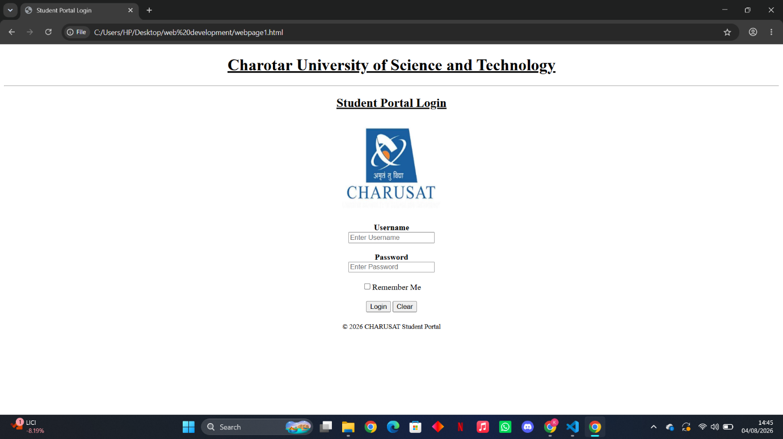
Home page:
Code:
<!DOCTYPE html>
<html lang="en">
<head>
<meta charset="UTF-8">
<meta name="viewport" content="width=device-width, initial-scale=1.0">
<title>Home Page</title>
<h1 style="text-align: center;""><u>Charotar University of Science and Technology</u></h1>
<hr>
</head>
<body style="background-color:white;">
<h1 style="text-align: center;"><u>Acedemic Portal</u></h1>

<div style="text-align: center;">
<a style="text-align: center;"href="webpage3.html">DashBoard</a>
</div>

<br>

<div style="text-align: center;">
<a style="text-align: center;"href="webpage4.html">Attendence</a>
</div>

<br>

<div style="text-align: center;">
<a style="text-align: center;"href="webpage5.html">Results</a>
</div>

<br>

<div style="text-align: center;">
<a style="text-align: center;"href="webpage6.html">Timetable</a>
</div>

<br>

<div style="text-align: center;">
<a style="text-align: center;"href="webpage7.html">Registered Courses</a>
</div>

<br>

<div style="text-align: center;">
<a style="text-align: center;"href="webpage8.html">FeedBack</a>
</div>

<br>

<div style="text-align: center;">
<a style="text-align: center;"href="webpage9.html">Announcements</a>
</div>

<br>

<div style="text-align: center;">
<a style="text-align: center;"href="webpage10.html">Notice</a>
</div>

</body>
</html>
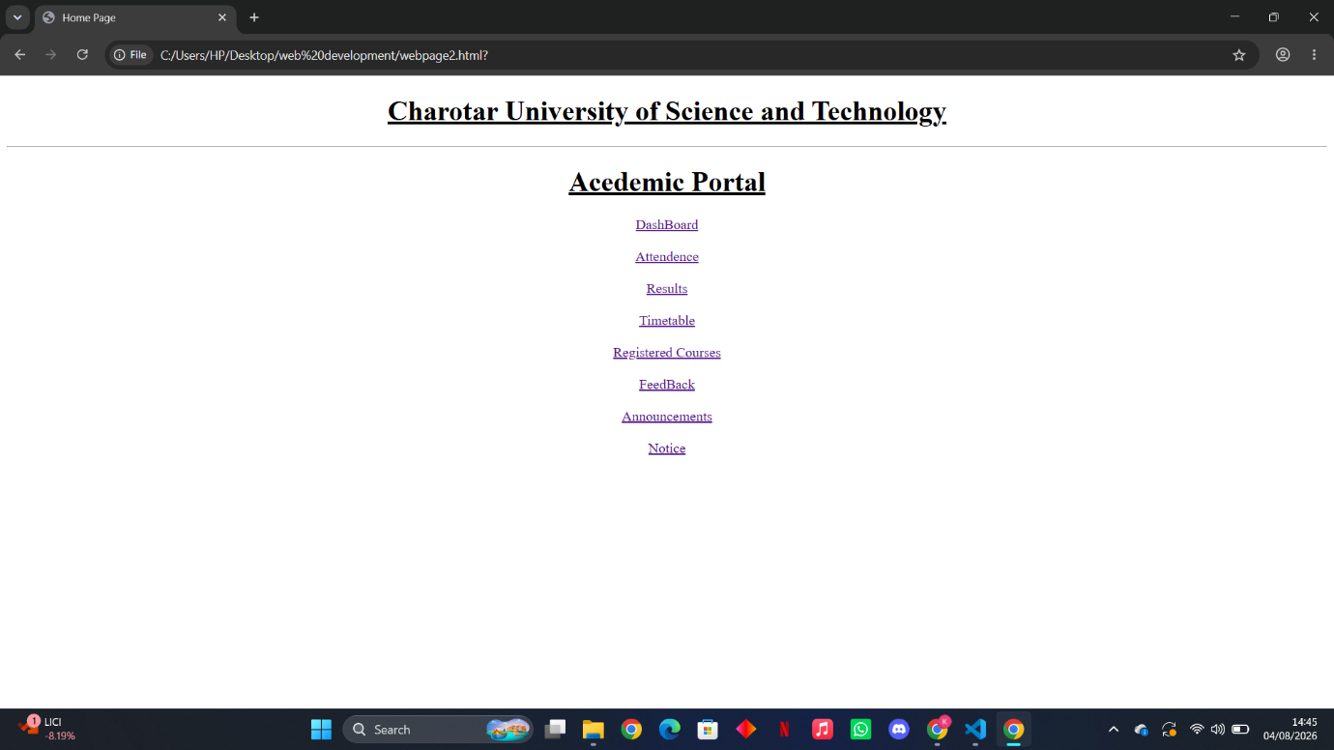
Dashboard
Code:
<!DOCTYPE html>
<html lang="en">
<head>
<meta charset="UTF-8">
<meta name="viewport" content="width=device-width, initial-scale=1.0">
<meta name="description" content="StudentHub Dashboard — View your academic summary, upcoming deadlines, and quick links.">
<title>Dashboard</title>
<h1 style="text-align: center;""><u>Charotar University of Science and Technology</u></h1>
<hr>
</head>
<body style="background-color: white;">
<section>
<h1 style="text-align: center;"><u>Student Dashboard</u></h1>
<h3 style="text-align: center;"><u>Welcome To Student DashBoard</u></h3>
</section>
<hr>
<section style="margin-left: 20%;margin: right 10%;">
<h2><u>Academic Summary</u></h2>
<table border="1" cellpadding="5">
<tr>
<th>Enrolled Courses</th>
<td>6</td>
</tr>
<tr>
<th>Pending Assignments</th>
<td>1</td>
</tr>
<tr>
<th>Attendance</th>
<td>67%</td>
</tr>
<tr>
<th>CGPA</th>
<td>7.9</td>
</tr>
</table>
</section>
<hr>
<section style="margin-left: 20%;margin: right 10%;">
<h2><u>Upcoming Deadlines</u></h2>
<table border="1" cellpadding="5">
<thead>
<tr>

<th>Course</th>
<th>Due Date</th>
<th>Status</th>
</tr>
</thead>
<tbody>
<tr>

<td>CSUC201 FUNDAMENTALS OF DATA STRUCTURE AND ALGORITHMS</td>
<td>2026-07-25</td>
<td>Pending</td>
</tr>
<tr>

<td>ITUE203 Web Development Frameworks</td>
<td>2026-07-23</td>
<td>Pending</td>
</tr>
<tr>

<td>CEUE203 OBJECT ORIENTED PROGRAMMING</td>
<td>2026-07-21</td>
<td>Pending</td>
</tr>
<tr>

<td>MSUD203 DISCRETE MATHEMATICS</td>
<td>2026-07-15</td>
<td>Submitted</td>
</tr>
</tbody>
</table>
</section>
<br>
<br>
<div style="text-align: center;">
<a href="webpage2.html">HOME PAGE</a>
</div>

</body>
</html>

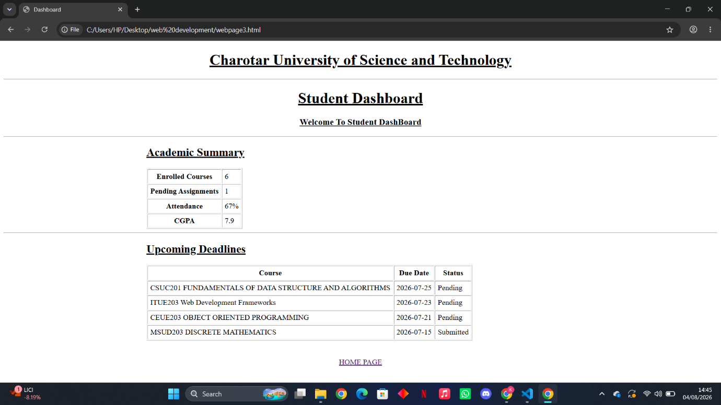

Attendance
Code:
<!DOCTYPE html>
<html lang="en">
<head>
<meta charset="UTF-8">
<meta name="viewport" content="width=device-width, initial-scale=1.0">
<meta name="description" content="StudentHub Attendance — View your overall and course-wise attendance records.">
<title>Attendance</title>
<h1 style="text-align: center;""><u>Charotar University of Science and Technology</u></h1>
<hr>
</head>
<body style="background-color: white;">
<section>
<h1 style="text-align: center;"><u>Attendance</u></h1>
</section>
<hr>
<section style="margin-left: 20%;margin: right 10%;">
<h2><u>Course wise Attendance</u></h2>
<table border="1" cellpadding="5">
<thead>
<tr>
<th scope="col">Course</th>
<th scope="col">Total</th>
<th scope="col">Present</th>
<th scope="col">Absent</th>
<th scope="col">Percentage</th>
</tr>
</thead>
<tbody>
<tr>
<td>CSUC201 FUNDAMENTALS OF DATA STRUCTURE AND ALGORITHMS</td>
<td>24</td>
<td>22</td>
<td>2</td>
<td>92%</td>
</tr>
<tr>
<td>ITUE203 Web Development</td>
<td>18</td>
<td>17</td>
<td>1</td>
<td>94%</td>
</tr>
<tr>
<td>CEUE203 OBJECT ORIENTED PROGRAMMING</td>
<td>22</td>
<td>20</td>
<td>2</td>
<td>91%</td>
</tr>
<tr>
<td>MSUD203 DISCRETE MATHEMATICS</td>
<td>20</td>
<td>18</td>
<td>2</td>
<td>90%</td>
</tr>
<tr>
<td>ITUC201 FUNDAMENTALS OF COMPUTER NETWORKS</td>
<td>18</td>
<td>17</td>
<td>1</td>
<td>94%</td>
</tr>
<tr>
<td>HSUV201 CREATIVITY,PROBLEM SOLVING AND INNOVATION</td>
<td>18</td>
<td>16</td>
<td>2</td>
<td>89%</td>
</tr>
</tbody>
</table>
</section>
<br>
<br>
<div style="text-align: center;">
<a href="webpage2.html">HOME PAGE</a>
</div>
</body>
</html>

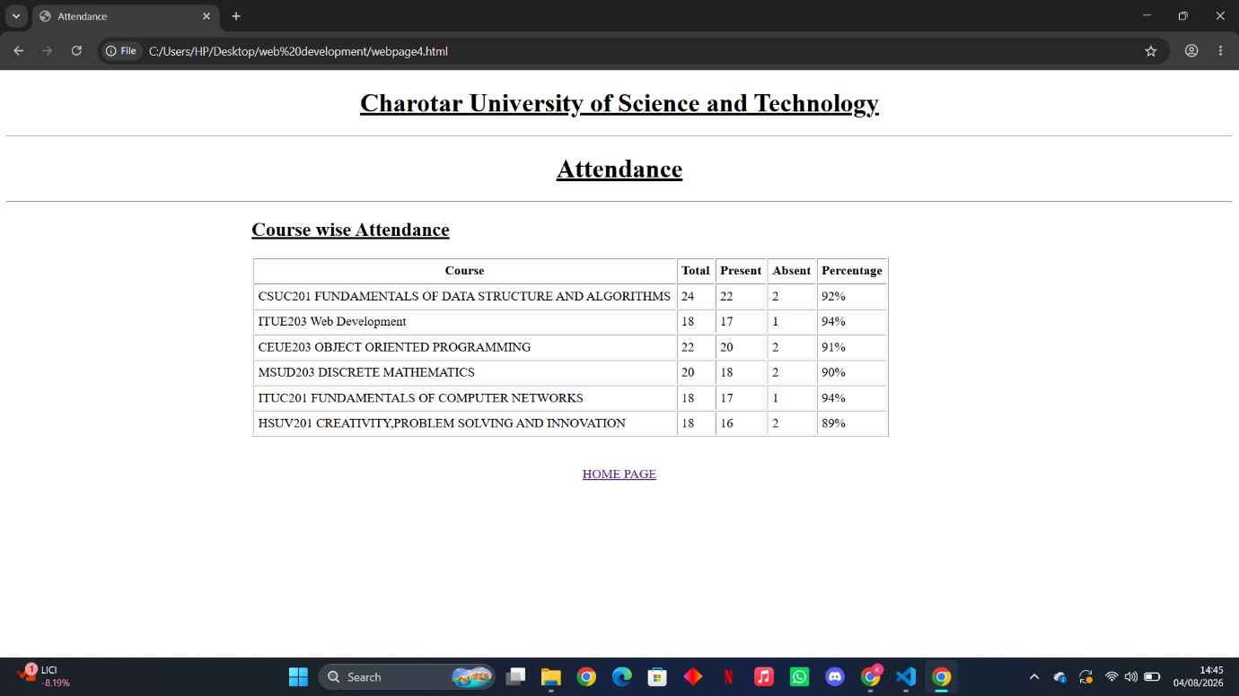

Results
Code:
<!DOCTYPE html>
<html lang="en">
<head>
<meta charset="UTF-8">
<meta name="viewport" content="width=device-width, initial-scale=1.0">
<meta name="description" content="StudentHub Results — View your academic results, grades, and SGPA for Semester 5.">
<title>Results</title>
<h1 style="text-align: center;""><u>Charotar University of Science and Technology</u></h1>
<hr>
</head>
<body style="background-color: white;">
<section style="margin-left: 20%;margin: right 10%;">
<h2><u>Results</u></h2>
<table border="1" cellpadding="5">
<tr>
<th>SGPA</th>
<td>8.7</td>
</tr>
<tr>
<th>CGPA</th>
<td>8.5</td>
</tr>
<tr>
<th>Credits Earned</th>
<td>42</td>
</tr>
</table>
</section>
<section style="margin-left: 20%;margin: right 10%;">
<h2><u>Subject-wise Results</u></h2>
<table border="1" cellpadding="5">
<thead>
<tr>
<th scope="col">Code</th>
<th scope="col">Course Name</th>
<th scope="col">Credits</th>
<th scope="col">Grade</th>
<th scope="col">Grade Points</th>
</tr>
</thead>
<tbody>
<tr>
<td>MEUD201</td>
<td>ELEMENTS OF ENGINEERING</td>
<td>4</td>
<td>A</td>
<td>9</td>
</tr>
<tr>
<td>CSUC201</td>
<td>FUNDAMENTAL OF DATA STRUCTURE AND ALGORITHMS</td>
<td>3</td>
<td>A+</td>
<td>10</td>
</tr>
<tr>
<td>ITUE203</td>
<td>WEB DEVELOPMENT FRAMEWORKS</td>
<td>4</td>
<td>A</td>
<td>9</td>
</tr>
<tr>
<td>CEUE203</td>
<td>OBJECT ORIENTED PROGRAMMING</td>
<td>4</td>
<td>B+</td>
<td>8</td>
</tr>
<tr>
<td>MSUD203</td>
<td>DISCRETE MATHEMATICS</td>
<td>3</td>
<td>A</td>
<td>9</td>
</tr>
</tbody>
<tfoot>
<tr>
<th colspan="4">SGPA</th>
<td>8.7</td>
</tr>
</tfoot>
</table>
</section>
<br>
<br>
<div style="text-align: center;">
<a href="webpage2.html">HOME PAGE</a>
</div>
</body>
</html>
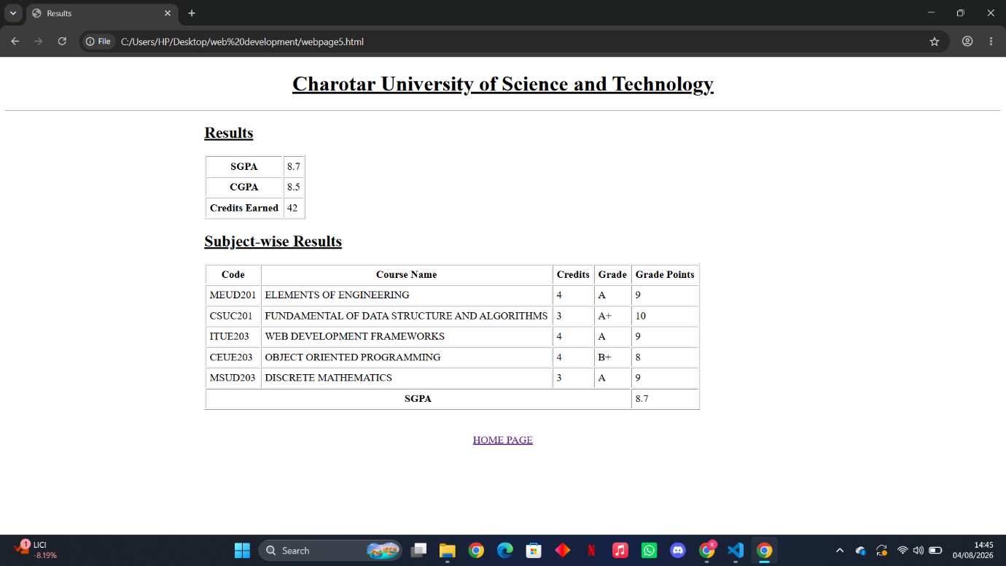

Timetable
Code:
<!DOCTYPE html>
<html lang="en">
<head>
<meta charset="UTF-8">
<meta name="viewport" content="width=device-width, initial-scale=1.0">
<title>Timetable</title>
<h1 style="text-align: center;""><u>Charotar University of Science and Technology</u></h1>
<hr>
<style>
table {
width: 100%;
}
table, th, td {
border: 2px solid black;
}
th, td {
padding: 5px;
text-align: center;
}
th:hover {background-color: #D6EEEE;}
td:hover {background-color: #D6EEEE;}
</style>
</head>
<body>
<header>
<h1 style="text-align: center;"><u>Timetable Schedule 3<sup>rd</sup> Semester</u></h1>
</header>
<main>
<table>
<tr>
<th scope="col">Day/Time</th>
<th scope="col">9:10-10:10</th>
<th scope="col">10:10-11:10</th>
<th scope="col">11:10-12:10</th>
<th scope="col">12:10-1:10</th>
<th scope="col">1:10-2:10</th>
<th scope="col">2:10-2:20</th>
<th scope="col">2:20-3:20</th>
<th scope="col">3:20-4:20</th>
</tr>
<tr>
<td>MONDAY</td>
<td>ITUE203:WDF</td>
<td>ITUC201:FCN</td>
<td rowspan="5">Lunch-Break</td>
<td colspan="2">ITUC201:FCN(P)</td>
<td rowspan="5">Short-Break</td>
<td colspan="2">CSUC201:FDSA(P)</td>
</tr>
<tr>
<td>TUESDAY</td>
<td>ITUC201:FCN</td>
<td>CEUC203:OOP</td>
<td>MSUD203:DM</td>
<td>COUNSELLING SESSION</td>
<td colspan="2">ITUE203:WDF(P)</td>
</tr>
<tr>
<td>WEDNESDAY</td>
<td>MSUD203:DM</td>
<td>CSUC201:FDSA</td>
<td>ITUC201:FCN</td>
<td>COUNSELLING SESSION</td>
<td colspan="2">ITUE203:WDF(P)</td>
</tr>
<tr>
<td>THURSDAY</td>
<td>CSUC201:FDSA</td>
<td>CEUC203:OOP</td>
<td colspan="2">HSUV201:CPI</td>
<tD>ITUE203:WDF</td>
<td>MSUD203:DM</td>
</tr>
<tr>
<td>FRIDAY</td>
<td>ITUE203:WDF</td>
<td>MSUD203:DM</td>
<td colspan="2">CEUE203:OOP(P)</td>
<tD>CSUC201:FDSA</td>
<td>ITUC201:FCN</td>
</tr>
</table>
<br>
<br>
<div style="text-align: center;">
<a href="webpage2.html">HOME PAGE</a>
</div>
</main>
</body>
</html>

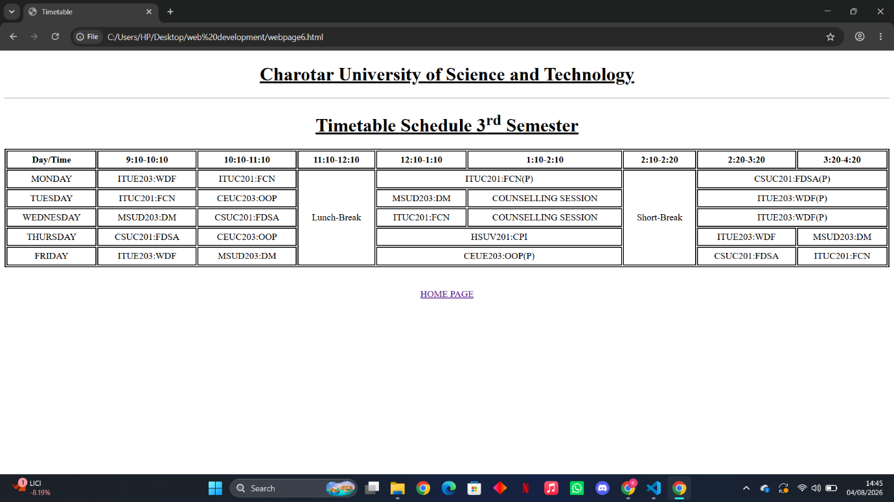

Registered Courses
Code:
<!DOCTYPE html>
<html lang="en">
<head>
<meta charset="UTF-8">
<meta name="viewport" content="width=device-width, initial-scale=1.0">
<meta name="description" content="StudentHub Courses — Browse the courses available this semester.">
<title>Registered Courses</title>
<h1 style="text-align: center;""><u>Charotar University of Science and Technology</u></h1>
<hr>
<style>
table {
width: 100%;
}
table, th, td {
border: 2px solid black;
}
th, td {
padding: 5px;
text-align: center;
}
th:hover {background-color: #D6EEEE;}
td:hover {background-color: #D6EEEE;}
</style>
</head>
<body>
<h2 style="text-align: center;"><u>Registered Courses</u></h2><hr>
<section style="margin-left: 10%; margin-right: 10%;">
<table border="1">
<tr>
<th>Code</th>
<th>Course Name</th>
<th>Faculty</th>
<th>Credits</th>
<th>Semester</th>
</tr>
<tr>
<td>ITUC201</td>
<td>FUNDAMENTALS OF COMPUTER NETWORK</td>
<td>Ms.Radhika Patel</td>
<td>4+1</td>
<td>Sem 3</td>
</tr>
<tr>
<td>CSUC201</td>
<td>FUNDAMENTALS OF DATA STRUCTURE AND ALGORITHMS</td>
<td>Mr.Akash Patel</td>
<td>3+1</td>
<td>Sem 3</td>
</tr>
<tr>
<td>ITUE203</td>
<td>WEB DEVELOPMENT FRAMEWORKS</td>
<td>Mr.Vaibhav Mataliya</td>
<td>3+2</td>
<td>Sem 3</td>
</tr>
<tr>
<td>CEUE203</td>
<td>OBJECT ORIENTED PROGRAMMING</td>
<td>Dr.Deven Gol</td>
<td>2+1</td>
<td>Sem 3</td>
</tr>
<tr>
<td>MSUD203</td>
<td>DISCRETE MATHEMATICS</td>
<td>Dr.Rajesh Savaliya</td>
<td>3</td>
<td>Sem 3</td>
</tr>
</table>
</section>
<br>
<div style="text-align: center;">
<a href="webpage2.html">HOME PAGE</a>
</div>
</body>
</html>

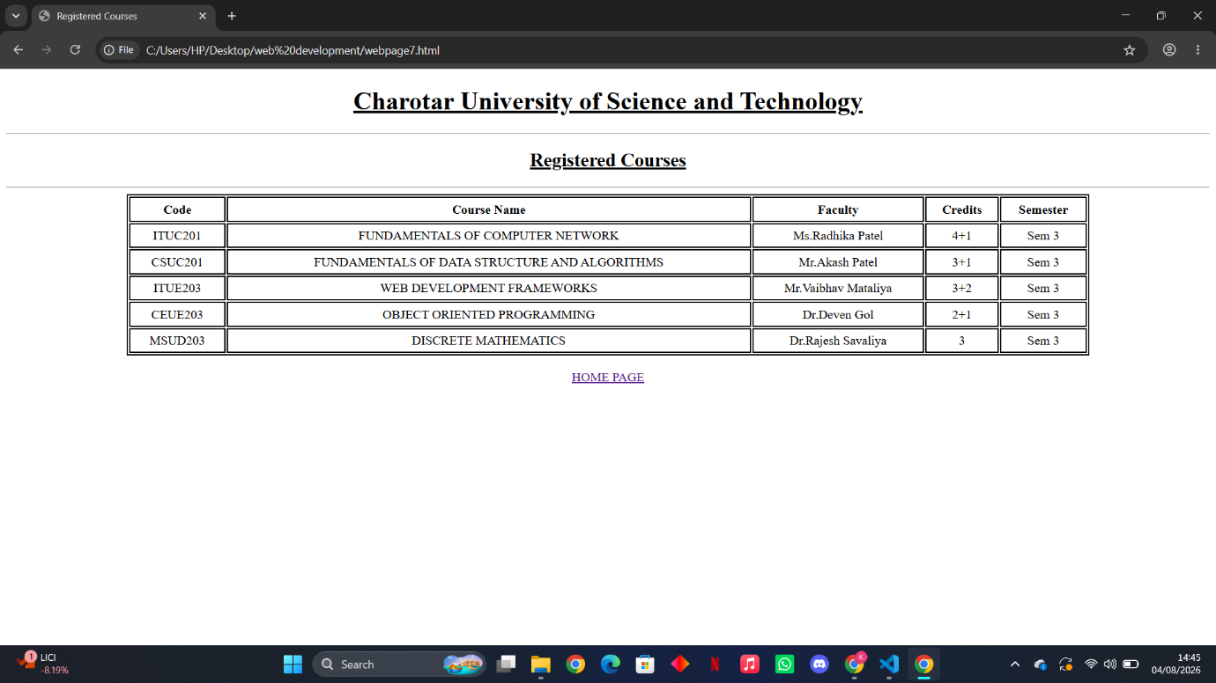

Feedback
Code:
<!DOCTYPE html>
<html lang="en">
<head>
<meta charset="UTF-8">
<meta name="viewport" content="width=device-width, initial-scale=1.0">
<title>Feedback</title>
<h1 style="text-align: center;""><u>Charotar University of Science and Technology</u></h1>
<hr>
</head>
<body>
<center>
<h1><u>Feedback</u></h1>
<p>"Your thoughts shape our roadmap. Share your feedback!"</p>
<form action="#">
<strong>How was your experience with the Portal?</strong>
<br><br>

<input type="radio" id="good" name="feedback" value="Good" required>
<label for="good">Good</label>

<input type="radio" id="average" name="feedback" value="Average">
<label for="average">Average</label>

<input type="radio" id="bad" name="feedback" value="Bad">
<label for="bad">Bad</label>

<br><br>

<strong>Is there anything that we could improve?</strong>
<br><br>

<label for="comment">Comment:</label><br>
<textarea id="comment" name="comment" rows="4" cols="30"
placeholder="Type your comment here"></textarea>

<br><br>

<input type="submit" value="Submit">
<input type="reset" value="Clear">
</form>

<hr>

<h3>Thank You!</h3>
<p>We appreciate your valuable feedback. Your suggestions help us improve our portal.</p>

<br>

<a href="webpage2.html">HOME PAGE</a>
</center>
</body>
</html>

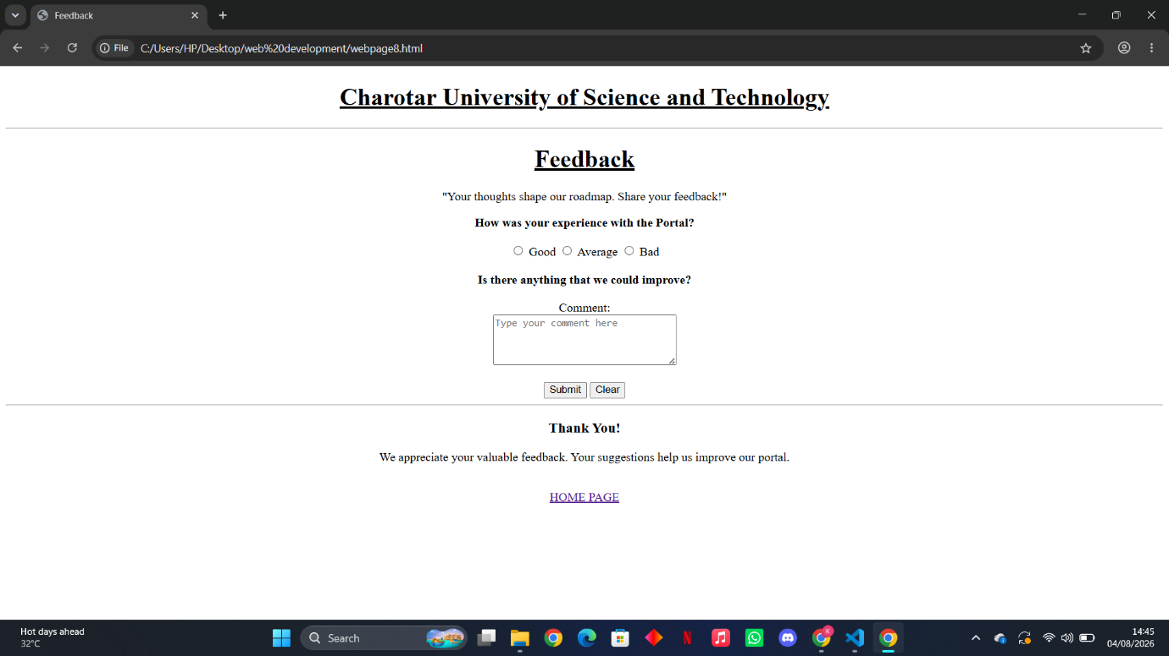

Announcements
Code:
<!DOCTYPE html>
<html lang="en">
<head>
<meta charset="UTF-8">
<meta name="viewport" content="width=device-width, initial-scale=1.0">
<title>Announcements</title>
<h1 style="text-align: center;""><u>Charotar University of Science and Technology</u></h1>
<hr>
</head>
<body>
<h2 style="text-align: center;"><u>Latest Announcements</u></h2>

<hr>

<h3>1.Mid-Semester Examination</h3>
<p>
The Mid-Semester Examination will begin on <b>15 September 2026</b>.
Students must carry their college ID cards and reach the examination hall
at least 30 minutes before the exam starts.
</p>

<hr>

<h3>2.Assignment Submission</h3>
<p>
The last date for submitting all pending assignments is
<b>10 September 2026</b>. Late submissions may not be accepted.
</p>

<hr>

<h3>3.Workshop on Web Development</h3>
<p>
A one-day workshop on HTML, CSS, and JavaScript will be conducted on
<b>20 September 2026</b>. Interested students can register through the
department office.
</p>

<hr>

<h3>4.Library Notice</h3>
<p>
The college library will remain open from <b>8:00 AM to 8:00 PM</b>
during the examination period to help students prepare.
</p>

<hr>

<h3>5.Holiday Notice</h3>
<p>
The college will remain closed on <b>2 October 2026</b> on account of
Gandhi Jayanti. Regular classes will resume the following day.
</p>

<hr>
<div style="text-align: center;">
<a href="webpage2.html">HOME PAGE</a>
</div>
</body>
</html>

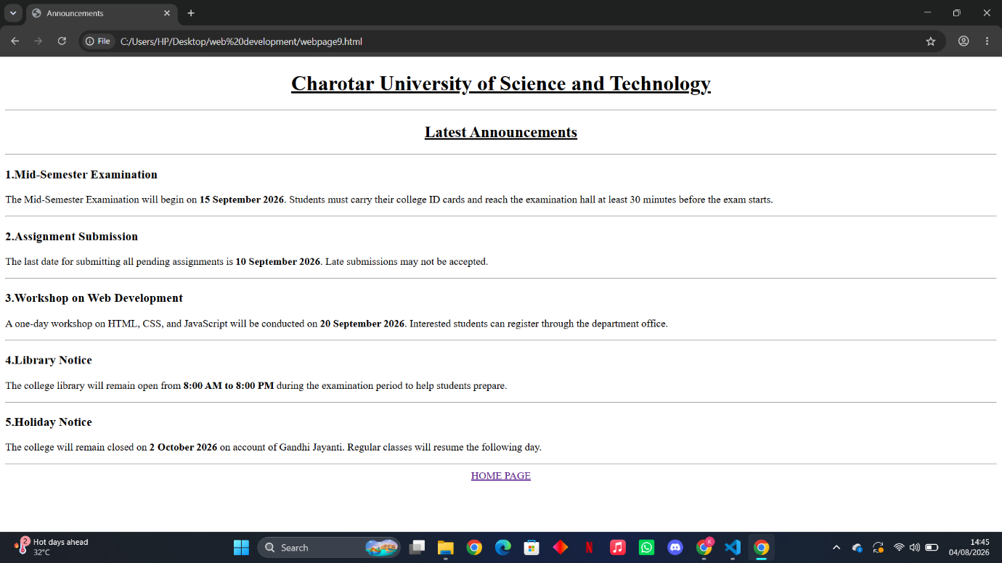

Notice
Code:
<!DOCTYPE html>
<html lang="en">
<head>
<meta charset="UTF-8">
<meta name="viewport" content="width=device-width, initial-scale=1.0">
<title>Notice</title>
<h1 style="text-align: center;""><u>Charotar University of Science and Technology</u></h1>
<hr>
</head>
<body>
<h2 style="text-align: center;"><u>Notices</u></h2>

<hr>

<ul>
<li>The last date to pay the semester fees is <b>30 September 2026</b>.</li>

<li>A late fee of <b>₹500</b> will be charged if payment is made after the due date.</li>

<li>Students must clear all pending fees before appearing for the semester examinations.</li>

<li>Fee receipts should be kept safely for future verification.</li>

<li>Any fee-related discrepancy should be reported to the Accounts Office within 7 working days.</li>

<li>Students can pay fees through UPI, Debit Card, Credit Card, or Net Banking.</li>

<li>No cash payments will be accepted without prior approval from the Accounts Department.</li>

<li>Scholarship recipients should submit the required documents before the fee deadline.</li>

<li>Students with pending dues may not be able to register for the next semester.</li>

<li>For any queries regarding fee payment, contact the Accounts Office during college working hours.</li>
</ul>

<hr>
<div style="text-align: center;">
<a href="webpage2.html">HOME PAGE</a>
</div>
</body>
</html>

